CO2/EXP3/Hardware
Multi-Byte Data and Array Operations Using 8086 Indirect Addressing

- To add two 32-bit (double-precision) numbers using register-indirect and based addressing with SI, DI and BX.

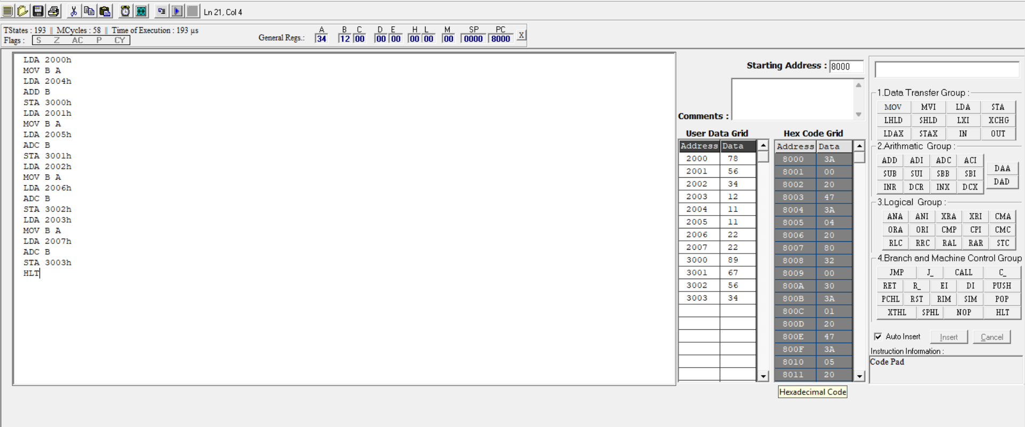
b) To find the sum of N 16-bit numbers stored in a word array with a 32-bit result using a loop.


